Firstly I give prompt to ChatGpt :
give me the prompt of anime website in which most popular or ranking wise watched anime are given and if you want to see the anime if you click on the anime you want to watch this anime play on new web page and the episode number are showing below also add the comment section,whatsapp contact section,instagram and other social media section add on home page and new page and all this sections are doing their on work properly and add some animations on home page and things which is important for making website also add this things in this website and the name of this website is HS Anime. Give me the prompt of making this website
Here’s a complete, professional prompt you can use with AI (like ChatGPT, Gemini,
Than ChatGpt Output Prompt:
Create a modern, responsive anime streaming website named “HS Anime” using HTML, CSS, JavaScript (and optionally React or Next.js for advanced features).
🎯 Main Features:
- Homepage (Landing Page):
  - Display most popular / top-ranked anime (based on views or ratings)
  - Anime cards with:
    - Thumbnail image
    - Title
    - Rating / views
    - Short description
  - Smooth hover animations and transitions
  - Navigation bar (Home, Popular, Categories, Contact)
- Anime Detail Page (New Page on Click):
  - When user clicks an anime → open new page
  - Show:
    - Anime video player (embedded player)
    - Full description
    - Genre, rating, release year
  - Episode list below video
    - Click episode → play in same player
  - Auto-play next episode (optional)
- Comment Section:
  - Users can:
    - Add comments
    - Reply to comments
  - Store comments using local storage or backend (Firebase preferred)
- Social Media & Contact Section:
  - Add on both homepage and anime page
  - Include:
    - WhatsApp contact button
    - Instagram link
    - Facebook / Twitter (X) links
  - Floating WhatsApp chat button
- Search & Filter System:
  - Search anime by name
  - Filter by genre, popularity, rating
- Animations & UI Design:
  - Use modern UI (dark theme preferred)
  - Add:
    - Page transitions
    - Card hover effects
    - Loading animations (spinner/skeleton)
  - Use CSS animations or libraries like AOS / Framer Motion
- Backend (Optional but Recommended):
  - Use Firebase / Node.js for:
    - Storing anime data
    - User comments
    - Authentication (optional login/signup)
- Responsive Design:
  - Mobile-friendly
  - Tablet & desktop optimized
- Extra Features (Important):
  - Bookmark / favorite anime
  - Recently watched section
  - Trending slider
  - Error page (404)
  - Footer with all social links

🎨 Design Requirements:
- Theme: Dark + Anime style
- Fonts: Clean modern fonts (like Poppins)
- Color palette: Black, purple, neon accents
- Smooth UX/UI like modern streaming platforms

🛠 Tech Stack:
- Frontend: HTML, CSS, JavaScript (or React)
- Backend: Firebase / Node.js (optional)
- Video: Embedded player (YouTube API or custom)

🎯 Goal:
Build a fully functional anime streaming website where users can:
- Discover popular anime
- Watch episodes
- Interact via comments
- Connect through social media
Putting this prompt on Loveable AI Tool and
Result:
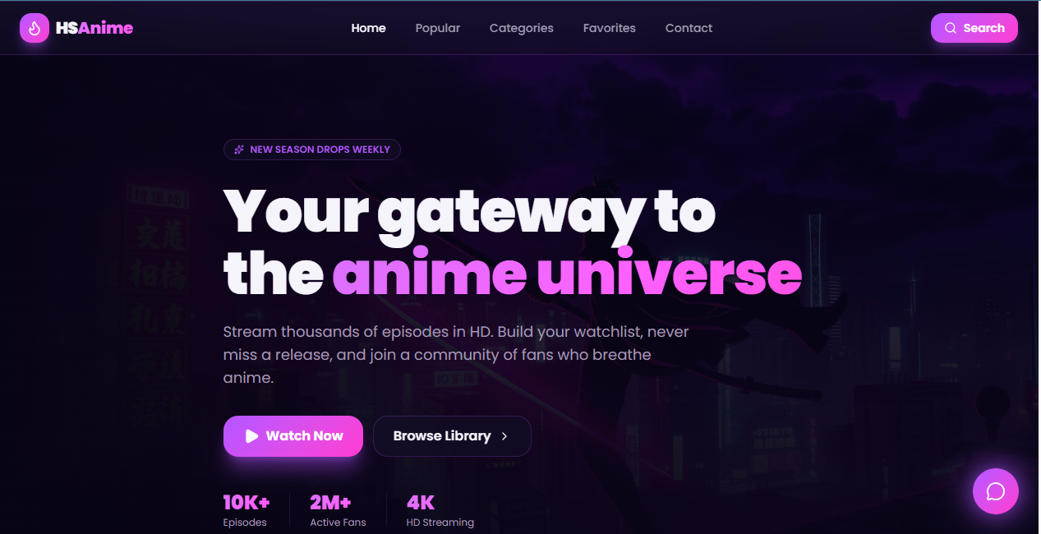
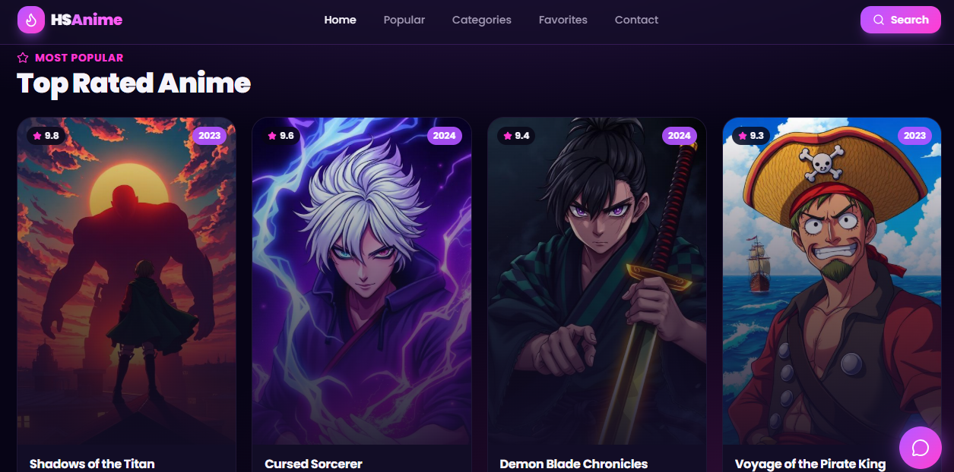
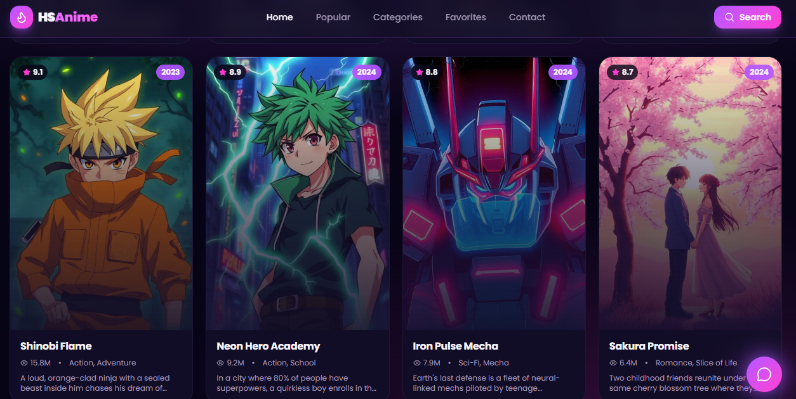
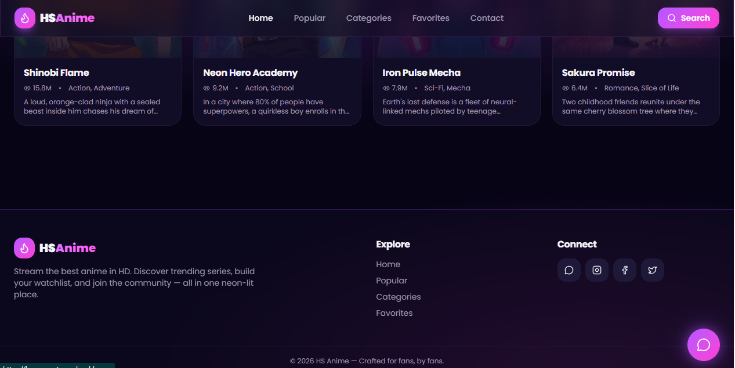
Link:
https://hs-wave-stream.lovable.app/

